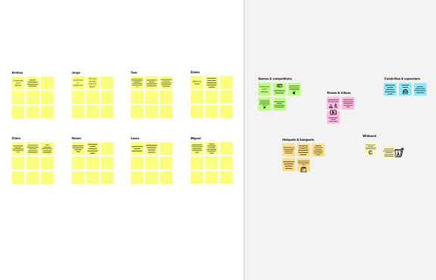

**Template**

Brainstorm

& idea prioritization

Use this template in your own brainstorming sessions so your team can unleash their imagination and start shaping concepts even if you're not sitting in the same room.

**10 minutes** to prepare

**1 hour** to collaborate

**2-8 people** recommended

**Share template feedback**

**Need some inspiration?**

See a finished version of this template to kickstart your work.

**Open example**

#### Before you collaborate



A little bit of preparation goes a long way with this session. Here’s what you need to do to get going.

**10 minutes**

1. **Team gathering**

Define who should participate in the session and send an invite. Share relevant information or pre-work ahead.

1. **Set the goal**

Think about the problem you'll be focusing on solving in the brainstorming session.

1. **Learn how to use the facilitation tools**

Use the Facilitation Superpowers to run a happy and productive session.

**Open article**

#### 1

**Define your problem statement**

What problem are you trying to solve? Frame your problem as a How Might We statement. This will be the focus of your brainstorm.

**5 minutes**

**PROBLEM**

**How might we [your problem statement]?**

#### Key rules of brainstorming

To run an smooth and productive session

Stay in topic. Defer judgment.

Encourage wild ideas. Listen to others.

Go for volume. If possible, be visual.



#### 2

**Brainstorm**

Write down any ideas that come to mind that address your problem statement.

**TIP**

You can select a sticky note and hit the pencil [switch to sketch] icon to start drawing!

**10 minutes**

**Patient details available live to the doctor**

**UI must be easy to access and navigate**

**medication suggestions can be given as per symptoms**

**system is not complex to understand**

**All information of the user will be safe and secured**

#### every part of

**keeping track of medications available and alerting if not**

**Update the user information frequently**

**Constant monitoring of a person**

**Alert message will be send to the patients when the doctor won't attend**

**healthcare**

#### data should

**be available**

#### in one place

**only the assigned doctor should be able to view their patient's details**

**Alerting the family through the details given by the person who is drowning**

**Data set is**

**created for**

**every user**

**and will be**

**maintained**

K



**Alert ambulance in the times of emergency**

**User friendly chatbot is developed for answering basic or common user queries**

**Doctors and mentors are given special access to users data in order to anaylse them better ang give consultation**

**Prevention of disease before it affects**

**Data transfer will be encrypted for security**

### Data is updated for every regular body checkup and

**If any discrepencies is noted from the data notifications is being sent**

**Data for current and previous checkup is constantly compared and sent as a report**

**remainder will sent to patients for their checkups**

**diagnoised results will be updated to doctor and patient automatically**

**software will be updated if there is new disease**

**analyse them**

**accordingly**

#### 3

**Group ideas**

**TIP**

Add customizable tags to sticky notes to make it easier to find, browse, organize, and categorize important ideas as themes within your mural.

Take turns sharing your ideas while clustering similar or related notes as you go. In the last 10 minutes, give each cluster a sentence-like label. If a cluster is bigger than six sticky notes, try and see if you and break it up into smaller sub-groups.

**20 minutes**

**Alerts**

**UPDATES**

**keeping track of medications available and alerting if not**

**Alert message will be send to the patients when the doctor won't attend**

**Alert ambulance in the times of emergency**

##### Update the user information frequently

**diagnoised results will be updated to doctor and patient automatically**

**If any discrepencies is noted from the data notifications is being sent**

# Security

**MONITORING**

**Constant monitoring of a person**



**All information of the user will be safe and secured**

**Data transfer will be encrypted for security**

##### keeping track of medications available and alerting if not

**only the assigned doctor should be able to view their patient's details**

**Doctors and mentors are given special access to users data in order to anaylse them better ang give consultation**

**4**



**Prioritize**

Your team should all be on the same page about what's important moving forward. Place your ideas on this grid to determine which ideas are important and which are feasible.

**20 minutes**

**Data set is**

**UI must be easy to access and navigate**

**created for**

**every user**

## and will be

**maintained**

**Alert ambulance in the times of emergency**

**Data transfer**

**will be encrypted for security**

**keeping track of medications available and alerting if not**

**Doctors and mentors are given special access to users data in order to anaylse them better ang give consultation**

#### Importance

If each of these tasks could get done without any difficulty or cost, which would have the most positive impact?

**medication suggestions can be given as per symptoms**

**diagnoised results will be updated to doctor and patient automatically**

**Alert message will be send to the patients when the doctor won't attend**

**All information of the user will be safe and secured**

**TIP**

**User friendly chatbot is developed for answering basic or common user queries**

Participants can use their cursors to point at where sticky notes should go on the grid. The facilitator can

confirm the spot by the laser pointer ho **H key** on the keybo

**Alerting the family through the details given by the person who is drowning**

**Prevention of disease before it affects**

using lding the ard.

#### Feasibility

Regardless of their importance, which tasks are more feasible than others? (Cost, time, effort, complexity, etc.)

#### After you collaborate



You can export the mural as an image or pdf to share with members of your company who might find it helpful.

#### Quick add-ons

1. **Share the mural**

**Share a view link** to the mural with stakeholders to keep them in the loop about the outcomes of the session.

1. **Export the mural**

Export a copy of the mural as a PNG or PDF to attach to emails, include in slides, or save in your drive.

#### Keep moving forward

**Strategy blueprint**

Define the components of a new idea or strategy.

**Open the template**

**Customer experience journey map**

Understand customer needs, motivations, and obstacles for an experience.

**Open the template**

**Strengths, weaknesses, opportunities & threats**

Identify strengths, weaknesses, opportunities, and threats (SWOT) to develop a plan.

**Open the template**

**Share template feedback**